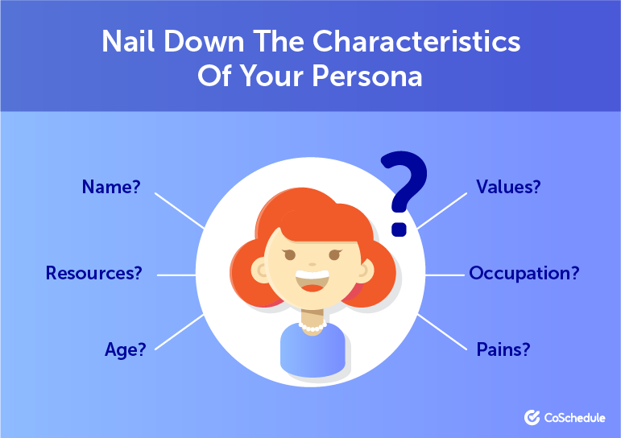

persona

Who uses this application

Which is characterized by this application, it does not specify a specific category of users in order to obtain a high service, this application for both doctors, engineers, businessmen, teachers, lawyers, judges, government officials, even students used by this application in organizing their lives Daily.

Because this application is like a secretary and assistant to each user in organizing and facilitating his practical life, and remind him of the most important dates he has and write the most important observations

 

 

 